Revenue Forecasting for New Releases - Entertainment Sector
Pooja Joshi & E.Code [E25007]

Overview :

The task for today involved analyzing a dataset of trending entertainment data to develop a revenue forecasting model for new movie releases. This included steps like data preparation, model building, and evaluation, with a focus on predicting revenue based on various factors such as popularity, vote average, and attendance count.

Objective:

Develop a robust model for forecasting revenue for new releases using machine learning algorithms, with the aim of making accurate predictions based on key movie metrics.

Assigned Task(s) :

· Load and prepare the dataset for analysis.
· Handle missing data, generate features, and estimate revenue.
· Build and evaluate a linear regression model.
· Build and evaluate a random forest model.
· Visualize key metrics and feature importance

Task Details :
Task 1: Data Preparation
- Status: Completed
- Details: The data was loaded and cleaned. Missing values in key columns like 'original_title' and 'release_date' were handled, and new features such as estimated_revenue were generated.
Task 2: Linear Regression Model
- Status: Completed
- Details: A linear regression model was built using features like popularity, vote average, and attendance count. The model showed a perfect fit with an R² of 1.0, though this might indicate overfitting.
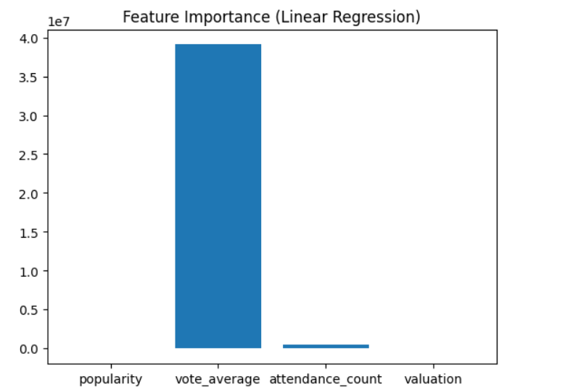
Task 3: Random Forest Model
- Status: Completed
- Details: A random forest regressor was built, cross-validation was applied, and hyperparameter tuning was performed. The final model performed well with an R² score of 0.99, showing better generalization compared to linear regression.
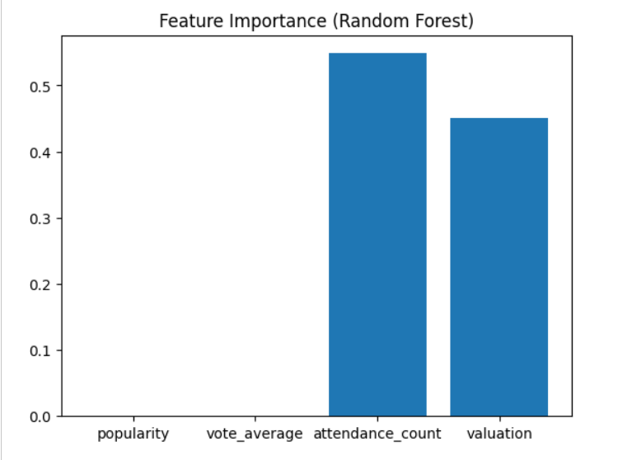

Visualizations
Here are some of the key visualizations generated during the analysis:

Correlation Matrix
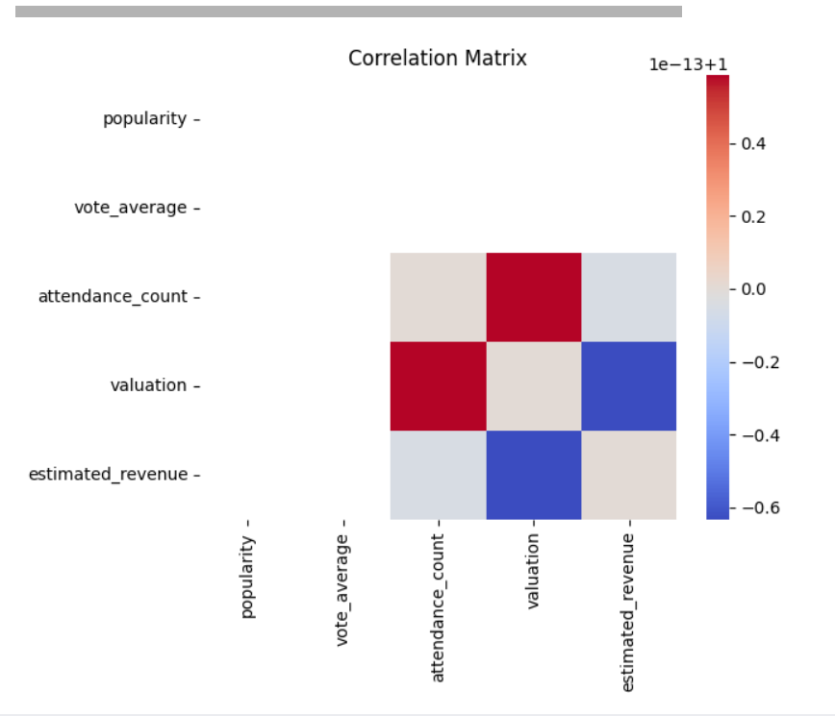
Distribution of Estimated Revenue
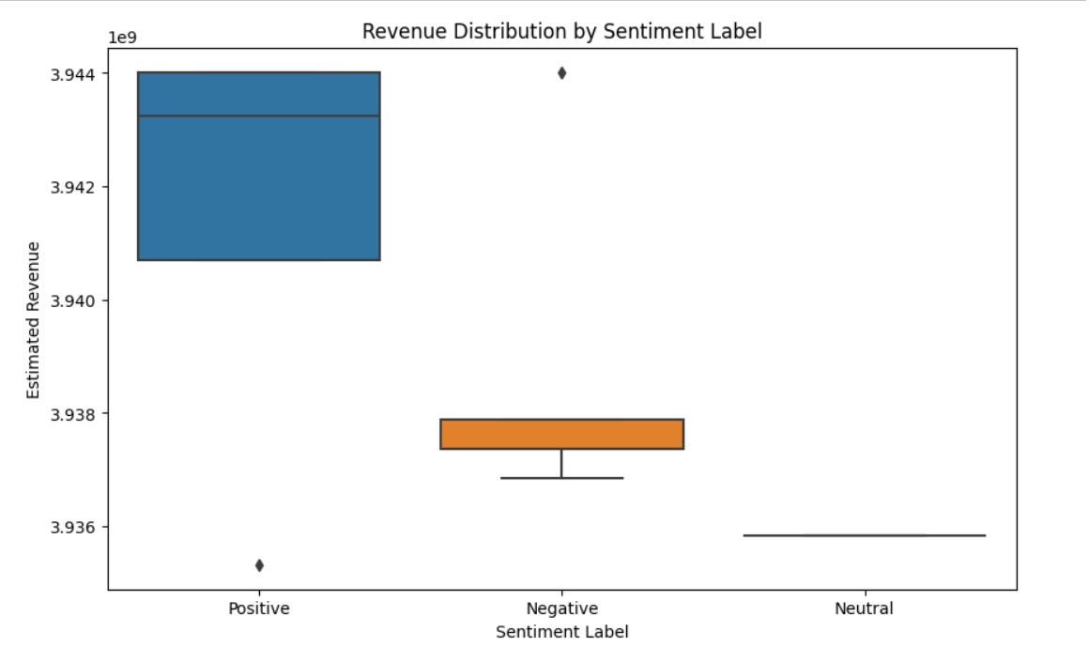
Actual vs Predicted Revenue (Scatter Plot)
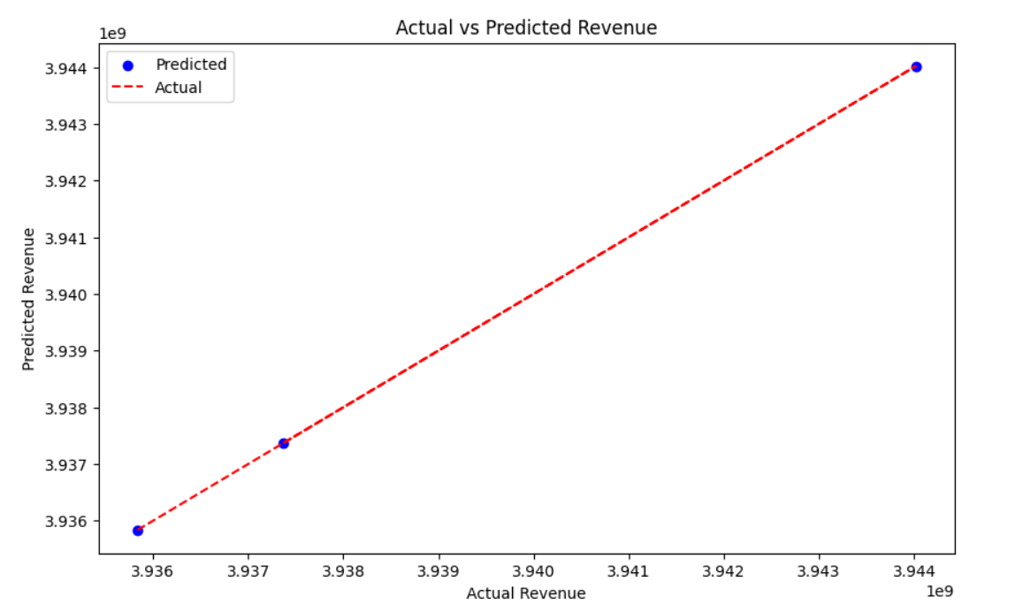
Residual Plot 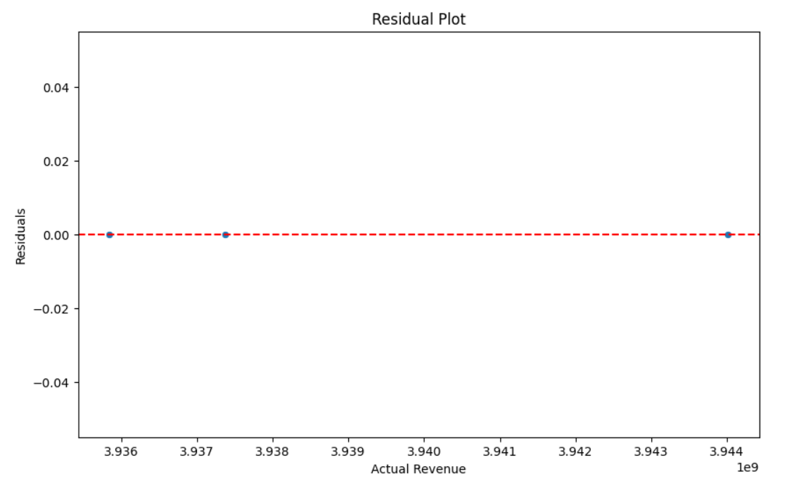

Estimated Revenue Over Time
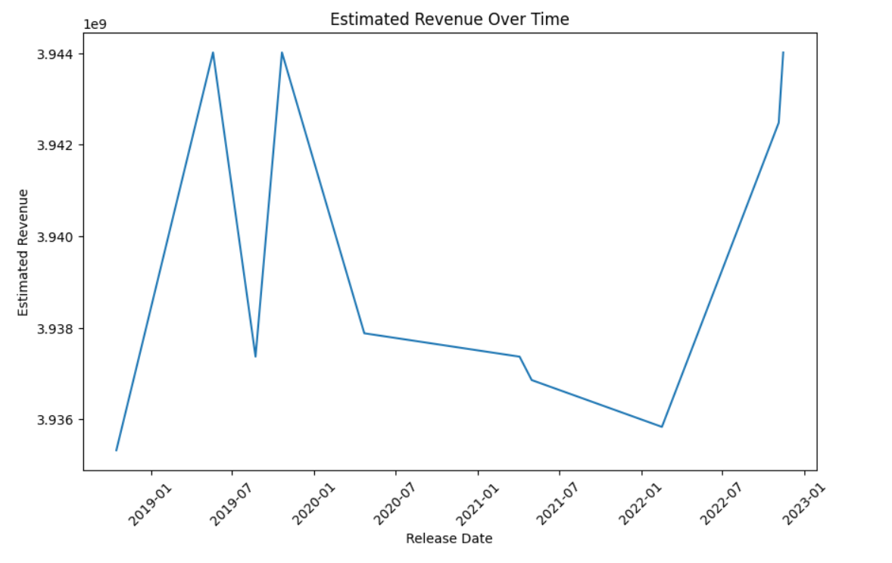

Progress :
Accomplishments:
  - Successfully cleaned and prepared the dataset.
  - Built and evaluated both linear and random forest models for revenue forecasting.
  - Added visualizations for actual vs. predicted revenue and feature importance.
Metrics:
  - Linear Regression: R² = 1.0
  - Random Forest: R² = 0.99 [TNR-12]

Challenges and Solutions :
Challenges Faced:
  - Missing release_date data affected the completeness of the dataset.
  - The perfect R² score in linear regression suggested overfitting.
Solutions Implemented:
  - Synthetic data was generated for missing release_date.
  - Random forest with cross-validation and hyperparameter tuning was applied to prevent overfitting.

Next Steps :
· Upcoming Tasks:
- Evaluate other machine learning models like Gradient Boosting for further improvement.
- Conduct feature engineering based on the genre or director to enhance predictive power.
· Goals:
- Improve the model's generalization by exploring advanced algorithms.
- Optimize feature selection to focus on the most relevant factors.

Conclusion :

Summary: This task involved building models for revenue forecasting using data from new movie releases. The random forest model showed strong performance, and visualizations helped highlight the importance of features like popularity and attendance count.

Acknowledgments: Thank the audience for their time and attention.

